2002-2011 – The Decade of the  Bone and Joint  The US Surgeon General Richard H. Carmona,MD issued a full report in 2004 outlining pertinent issues and national prevention and treatment strategies dedicated to better bone health. As stated in his executive summary “ An estimated 10 million Americans over age 50 have osteoporosis (the most common bone disease), while another 34 million are at risk. Each year an estimated 1.5 million people suffer an osteoporotic-related fracture, an event that often leads to a downward spiral in physical and mental health. In fact, 20 percent of senior citizens who suffer a hip fracture die within 1 year. One out of every two women over 50 will have an osteoporosis-related fracture in their lifetime, and the risk of fracture increases with age. Due primarily to the aging of the population and the previous lack of focus on bone health, the number of hip fractures in the United States could double or even triple by the year 2020”.  A national initiative is currently underway to educate the population in prevention of disease and preservation of bone health. With appropriate nutrition and physical activity throughout life, individuals can significantly reduce the risk of bone disease and fractures.   Specialty Defined: Chiropractic Neurology  As in medicine and dentistry, there are specialists within the chiropractic profession. A chiropractic neurologist typically works with patients who have neurological, psychological or musculoskeletal disorders. They offer adjunctive care to commonly used regimens that is non-pharmaceutical and non-invasive. This enables patients to reach a higher level of function and relief. Chiropractic neurology has been proven effective in treating a spectrum of disorders including chronic pain, headaches, AD(H)D, Tourette’s Syndrome, Autism, Asperger’sSyndrome, disorders of balance and dizziness.  The schooling to become a board certified chiropractic neurologist involves an additional two years of course work after completing the Doctor of Chiropractic degree. In addition self- study and | The Front Supports the Back  In one precise position, the skeleton supports the body in an upright posture. Slight deviation from the “perfect” alignment causes muscles to engage to assist in upright support. Large muscles located centrally stabilize our bodies while smaller muscles move us. This is a generalization, since the larger muscles do contribute to motion, but their primary action is to maintain posture.  There are large bones called vertebrae that stack one upon the other forming the spinal column. The column measures approximately 3 inches across and serves as our main support structure. Such a base of support seems inadequate to balance an entire body. The body relies on long rows of muscles that start at the skull and end at the pelvis for added support. The true diameter of a body’s base of support is increased by the diameter of the entire midsection, around the abdomen. The stronger the abdominal muscles, the more they contribute to core support.  Back pain is often treated in part by use of a corset brace. This wide belt, usually elastic, wraps around the midsection. By adding the brace, one increases the circumference of the base of support. The weight of the body is now distributed over a larger area, reducing the work done by the structures of the back. If the abdominal wall is strengthened, it can act like a natural brace increasing the functional circumference of our base of support. This is the main reason abdominal strengthening is so important in maintaining a healthy back.   practical application are required. All course work is conducted under the auspices of an accredited institution recognized by the U.S. Department of Education and the National Organization of Certification Agencies. After the completion of this post-graduate work, candidates sit for a board examination in front of an independent examining board.  A Chiropractic Neurologist takes a complete history that includes new, ongoing, and past health issues. Relevant factors of lifestyle and occupation are also taken into consideration. A thorough examination is done involvingspecific neurological, vestibular, and musculo- skeletal tests. If necessary x-ray or MRI of a problem area may be recommended. The goal is to determine the level of function of | FUN FACT:  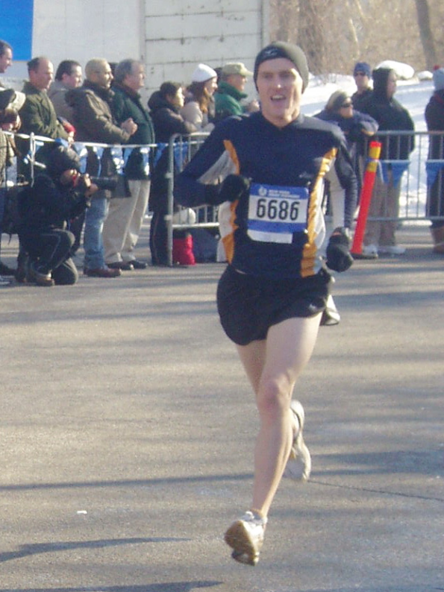  When we walk one foot leaves the ground to advance the body forward while the other foot maintains contact with the ground keeping us stabile. When we run, both feet leave the ground.  Kevin Doherty, DC  Chiropractor  Chiropractic Neurology  777 West End Avenue  Suite 1B  New York, NY 10025  212 – 280 - 7774  each of your body’s systems. Based on the  knowledge gained from the history and exam, an individualized therapeutic trial is designed. You are tested during and immediately following this trial to determine the effectiveness of care and to make any necessary alterations. Prior research coordinated with your individual needs dictates the design of each individual program. Protocols may include: specific adjustments to joints, sensory stimuli including light, sound, smell, and touch, active therapies to improve muscle tone, coordination, flexibility, and balance, breathing exercises, soft tissue treatments such as trigger point work, postural exercises, eye exercises, cognitive drills and lifestyle and nutritional counseling.

Plantar Fasciitis  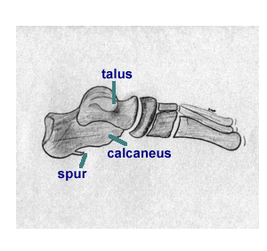  Heel spurs are the best known heel problem, but plantar fasciitis is the most frequently encountered cause of heel pain. A heel spur is a focal point of bone growth on the heel. The bone growth usually extends forward towards the toes. Heel spurs are visible on X-ray.  The term plantar fasciitis is derived from plantar which refers to the bottom of the foot and fascia which is a type of dense fibrous connective tissue. The plantar fascia connects the area of the foot near the toes with the heel. Pain arises when the plantar fascia is irritated or even torn. The problem usually occurs at the fascia’s attachment to the heel bone (calcaneus) which results in either a heel spur forming (from the injured bone attempting to heal itself) or in plantar fasciitis. Pain and tenderness are usually centered at a location just in front of the heel toward the arch.  The "itis" is a suffix that means inflammation. Latest studies show that in many cases of plantar fasciitis there really is no inflammation, but rather an avascularity ( loss of blood circulation ). If your foot flattens or becomes unstable during critical times in the walking or running cycle, the attachment of the plantar fascia into your heel bone may begin to stretch and pull away from the heel bone. This will result in pain and possibly swelling. The pain is especially noticeable when you push off with your toes while walking since this movement stretches the already irritated portion of the fascia. Without treatment the pain will usually spread around the heel. When tearing occurs at the bone itself, it heals by producing new bone. This results in the development of a heel spur. With or without the spur the condition is called plantar fasciitis.  The pain of this condition may cause you to try to walk on your toes, or alter your running stride and gait which will cause further damage and may cause a problem to develop in your healthy foot. Gait changes in running may also lead to ankle, knee, hip or back pain. | The most effective way to treat plantar fasciitis is to increase the flexibility of the fascia by stretching. Stretching the calf, Achilles tendon and foot are essential to alleviate harmful stress across the bottom of the foot. Try freezing water in a plastic 16 ounce bottle, and then roll your foot on this for 8-10 minutes a few times a day. The rolling will gently stretch the fascia, and the ice provides analgesia as well as therapeutic reduction of any swelling. If your pain persists for more than two weeks, consult a physiatrist who will prescribe physical therapy or treat the pain directly with an injection of steroid to locally treat the problem.  Try This:  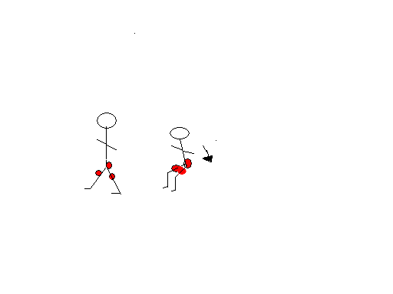 Squat – Quadriceps, hamstrings and gluteii  Food Figures  The American Diabetes Association (ADA) recommends a daily caloric intake of 1600 – 2800 calories. Foods from different groups, about 6 servings of grain, 5 servings of fruits and vegetables, 2 servings of dairy and 4-6 ounces of lean meat should provide this caloric total. The optimal schedule for caloric consumption depends on individual needs and traits and cannot truly be generalized. Consider why one must eat. Food provides energy required by every component of our bodies. Food as fuel should be supplied based on a body’s needs. Late at night before bed, one needs little energy as the body prepares for a rest phase. On awaking each morning, the body has been in a fasting state for 4-6 hours and needs fuel to function. The food choices made in the morning, and consideration of the activities planned for the day dictate when the next meal is needed. A breakfast of carbohydrates, provides immediate but short acting energy. If the activities planned for the morning include exercise, travel or other exertions, then the next meal should be planned for early in the day. A breakfast of proteins provides energy at a slower rate but for a longer time span, since proteins require more complex  processes for metabolism but remain actively available longer. So lunch could be planned for | A later time. The concept of eating three meals a day was based on one eating three carefully planned, well balanced meals that would provide adequate energy for the next 4-6 hours. In reality though, meals are rarely optimally balanced for content and time. This led to the suggestion that a healthier eating schedule might include six smaller meals, placing less reliance on the quality of food sources for providing energy. Smaller, more frequent meals allow for a more reliable, consistent source of fuel regardless of the food group. Research revealed additional benefits to eating more frequently: maintaining a higher metabolic rate for longer periods each day; preventing extreme fluctuations of blood insulin and glucose levels promoting more efficient metabolism; avoiding symptoms of hunger and circadian “lows” that can be so distracting to ones’ activities.  With so many “diet” plans being touted one must assess individual needs when deciding how to eat. Recognize when your energy demands are greatest and supply quality fuels for those times. If you need help, keep a diary recording what you eat, at what time, and how you feel afterwards. Remember food is essential and eat wisely.  Did you know?  Shower and tub falls rank as the third leading cause of accidental death in the 50-plus age group. More than half of all accidents could be prevented with some sort of environmental modification.  Stacey Jaff, MD  Board Certified Physiatrist  Address all Correspondence to:  382 Central Park West #20V  New York, NY 10025  Telephone (212) 222-1007  Fax (212) 722-7686  Office Address:  43 Central Park North, 1B  New York, NY 10026  Office Hours:  Monday through Friday 8AM –7:30PM

