Are You Using the Right Drug?  The general population turns to the media for information, and manufacturers of over the counter pharmaceuticals capitalize on this using sympathetic, entertaining and provocative advertising to increase awareness of their products. What one truly needs to know about the many drugs available for purchase without a doctor’s prescription is the action of that medication, what it can treat. In practice I find so many patients who cannot distinguish between classes of drugs based solely on what they learn from advertisements.  Tylenol, Motrin, Advil and Aleve are among the most frequent drugs promoted. As a physician I find this appropriate, for these are probably the most useful drugs for the population to use without consulting a professional. These drugs have been tested extensively and their risks and benefits accurately shown to be safe and effective. And they have stood the test of time, each having been on the market for over 10 years. I find that patients do not truly understand the proper uses for these medications and that can lead to unnecessary risks, side effects or frustration. It is a common misconception that Tylenol, Advil, Aleve and Motrin work well to rid oneself of mild pain, but when seriously injured or if the pain is severe one must seek stronger medicine. More than likely, people can find the relief they need on their medicine shelves at home, if only they understand how to correctly use these drugs. In addition, patients believe these drugs are  interchangeable but there are some major differences that all should know. Advil, Aleve and Motrin all belong to a class of drugs known as non-steroidal anti-inflammatory drugs (NSAIDS). Advil and Motrin contain 200mg of Ibuprophen, and Aleve has 220mg of Naproxen Sodium. These drugs target inflammatory processes in the body. The majority of the pain relief one gets from using these medications comes from treatment of that inflammation,  Physiatry  The field of medicine that focuses on how disease and impairment affect function. Physiatrists work with you to preserve your autonomy of motion | just as one treats an infection with antibiotics to  rid the body of that infection. Note that these drugs also have a direct effect on treating pain. Tylenol (active ingredient acetaminophen) does not treat inflammation but is a powerful tool when treating pain from many sources. Knowing this, one might deduce that it is prudent to buy an NSAID and use it for all pain needs. In this way, one only need purchase one product, saving money and space. However there are real benefits to using Tylenol over NSAIDS.  FYI  Tylenol Arthritis and Tylenol Eight Hour are the same drug, labeled differently to target two distinct populations. To establish therapeutic blood levels of the active ingredient, one should take two tablets three times a day until they have at least two pain free days.  Although safe for frequent use, there are possible side effects with NSAIDS use. One can develop irritation of the gastrointestinal tract leading to heartburn, gas and even ulcers. The risk of these side effects will vary based on how often the drugs are used, at what dose, and also on an individual’s sensitivity to each active ingredient. The risk of side effects is low, but since these drugs are used so often by so many people, the actual incidence of medical complications as a result of using NSAIDS in this country is quite high. The point is that, although these drugs are very safe to use, even for long periods of time, there are some risks. In medicine, we strive to minimize risks whenever possible. Tylenol offers a risk reducing option when treating pain. When your pain is caused by a soft tissue injury, surgery, degenerative arthritis, simple headache or fracture your symptoms of pain will likely be treated with therapeutic doses of Tylenol. If you have developed pain from overuse or strain, like in tendonitis, bursitis, or just “overdoing it”, or have an inflammatory disease such as rheumatoid arthritis, all conditions where inflammation is the most likely cause of the pain, using an anti-inflammatory drug will treat the condition, eradicating the symptoms. Distinguishing these classes of drugs improves your response to treatment and your risk of medical complications and should be taken seriously  | Ice or Heat  Both increase blood flow to an injured area, increasing oxygen and nutrient supplies and enhancing healing.  Ice interrupts the neurologic misfiring that causes a muscle to spasm when it is fatigued. Ice will relax the spasm . Heat will not.  A Strong Stomach Cures Back Pain  Muscles work in pairs, one the agonist, the other the antagonist as they mobilize a joint. Due to a physiologic mechanism called reciprocal inhibition, when one member of the pair contracts, the other relaxes. People with back pain often wonder why a doctor will insist they strengthen their abdominal muscles by doing crunches to help treat their symptoms. The abdominal and back muscles are agonist/antagonist to each other. When done correctly crunches will strengthen the abdominal muscles while stretching the back muscles. Look for the next issue of this newsletter for an explanation of how strengthening the abdominal muscles alleviates back pain   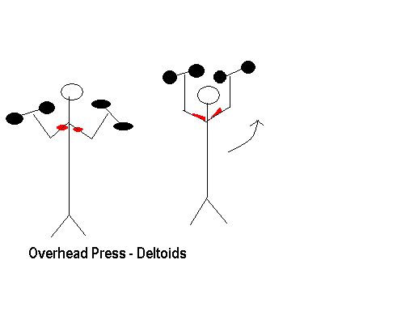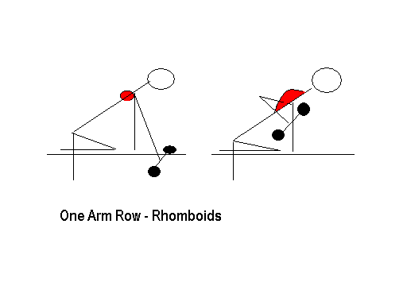Try These:

The Pinched Nerve  What people call a pinched nerve is a nerve that is being compressed by some adjacent structure. Compression of a nerve will cut off the blood supply to the nerve fibers decreasing the oxygen and nutrients that can get to it. The first symptom one notices when this happens is an uncomfortable tingling sensation around the area. This sensation changes to pain after as little as ten minutes, a result of ischemia which is lack of oxygen flow to any tissue. If the compression on the nerve continues, the next symptom one experiences is numbness, or loss of sensation in the area supplied by that nerve. If the compression is total, completely blocking the nerve’s transmission of chemical signals, the structures usually supplied by that nerve will stop functioning. This would result in muscle weakness, tissue atrophy and skin quality and color changes. More often, when there is compression of a nerve, it is partial, with some signals blocked but some continuing to get through the “pinched” area. When this occurs, instead of frank numbness, one might complain of persistent tingling, and sensation of pain, burning, and/or an ice cold feeling.  A common cause of partial nerve compression is swelling of a nearby structure, such as a muscle. When there is swelling fluid collects in the tissue, first taking up space and pressing the normal structures more tightly together; second increasing the spaces between structures and their blood supply, and thus decreasing the delivery of oxygen and nutrients, or nerve signals, to the structure. This often results in symptoms of nerve injury even though the damaged tissue is not nerve. All the same symptoms one feels with a true nerve compression may be present, though the nerve itself is not damaged. A physician can differentiate these conditions by taking a careful history from a patient, and doing a comprehensive physical examination.  When a clinical evaluation identifies that a nerve is irritated and may be damaged, further diagnostic testing is appropriate. Nerve conduction studies and electromyography are tests that can evaluate nerve function and identify if nerve injury exists. This test can also identify the place the nerve is injured along its path. An MRI of the area might help identify the source of nerve compression if clinical evaluation alone can not. The treatment involves removing the source of compression, which is why accurate diagnosis is so important. One must differentiate between an intrinsic disease deteriorating the nerve, the presence of a mass pushing against the nerve or a swollen structure compressing the nerve. Oral and injected medications, physical therapies, the use of braces, and surgery are the most common forms of treatment. | Try This:  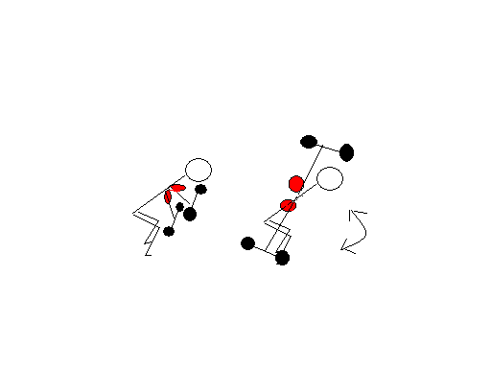  Bent Over Fly – Posterior Deltoids  Physiatrists Can Help You Move  A physiatrist is a physician specializing in restoring functional abilities. Their medical training includes four years of medical school, a general internship and then a specialty residency in physical medicine and rehabilitation. Board certification is available through the American Board of Physical Medicine and Rehabilitation after completion of their training, two years of clinical experience and success with a written and an oral examination.  A physiatrist is trained to treat illness and impairment representing a vast variety of medical disciplines. Rehabilitation includes specialty treatment of traumatic brain injuries, spinal cord injuries, stroke and amputation. It addresses patients’ needs after major illnesses or catastrophic events such as heart attack, major surgery, prolonged hospital stays, motor vehicle and other traumatic accidents. Physical medicine deals with diseases and injuries involving the muscles, nerves, bones, skin, joints, tendons and ligaments. Extensive knowledge in orthopedics, neurology, rheumatology, endocrinology, therapeutic oncology and vascular medicine are basic elements of any physiatrist’s fund of knowledge. Aspects of functional loss and pain known in diseases like multiple sclerosis, lupus and peripheral neuropathy, as well as mechanical disruption seen with fractures, arthritides, and sports, or activity related overuse or strains represent just a portion of what they can treat.  Physiatrists rely heavily on the history they extract from a patient and the physical findings identified on examination to identify a diagnosis and design a treatment plan. They use radiographic studies, perform electro diagnostic | nerve tests and a variety of injections to optimize treatment options and outcomes. They work together with therapists of many disciplines (physical, occupational, speech, massage) to achieve projected goals. If you have pain or impaired mobility; if you have changed the things you do in life because they have become too difficult; if you require assistance in daily activities when you used to be independent then you might benefit from consulting a physiatrist. Autonomy is a precious gift that must be nurtured. Aging does not have to be associated with loss of activity and increasing pain. We all must stay in shape to live our lives. Take control, minimize pain, maximize function, for always  FYI  A broken bone heals over the course of 6 months. Full remineralization of the bone and remodeling of the area continues slowly and is influenced by the forces placed across the fracture site.  The pain from a fracture should last 6 weeks. After this time, there has been adequate healing for a secure scar or callus as it is called, to secure the fractured area.  Stacey Jaff, MD  Board Certified Physiatrist  Address all Correspondence to:  382 Central Park West #20V  New York, NY 10025  Telephone (212) 222-1007  Fax (212) 722-7687  Office Address:  43 Central Park North 1B  New York, NY 10026  Monday and Wednesday  8AM – 8PM

